**AWS Document Database**

* Some applications represent the data as JSON document and the populare database for doing that is mongo db
* Amazon Document DB (with Mongo DB Compatibility) is a fast, scalable and highly available and fully managed document database service that supports Mongo DB Workloads
* Amazon Document DB is compatible with Mongo DB 3.6 and 4.0 APIs
* Functional Differences between Document DB and Mongo DB <https://docs.aws.amazon.com/documentdb/latest/developerguide/functional-differences.html>
* AWS Document Database has memory optimized and Burstable Performance like RDS instances
* Lets Create a Document Database and explore the options  
  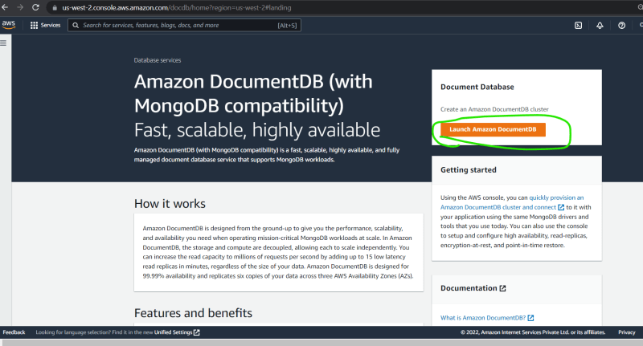  
  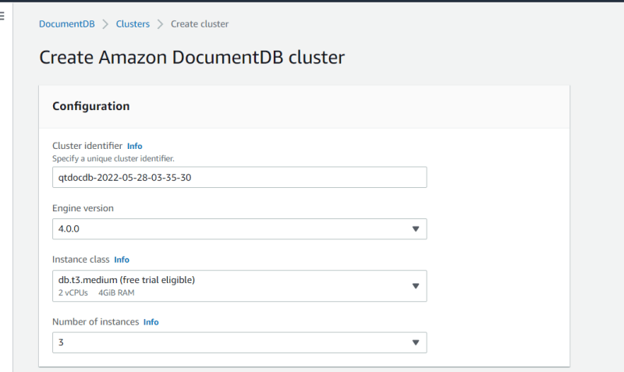  
  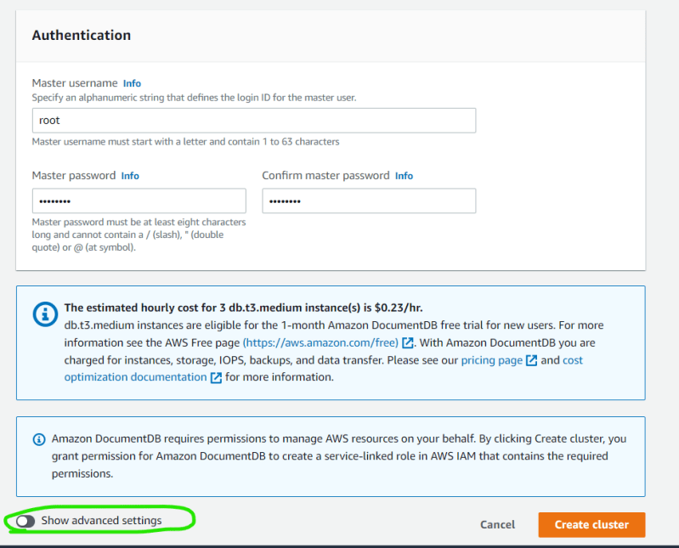  
  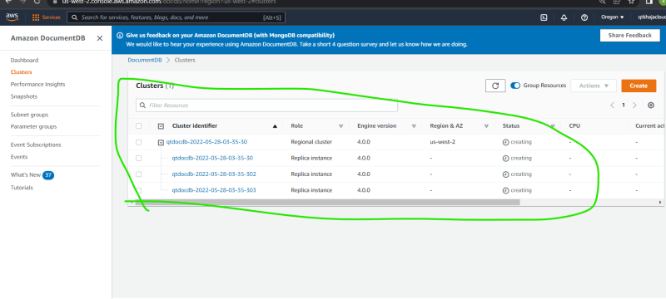  
  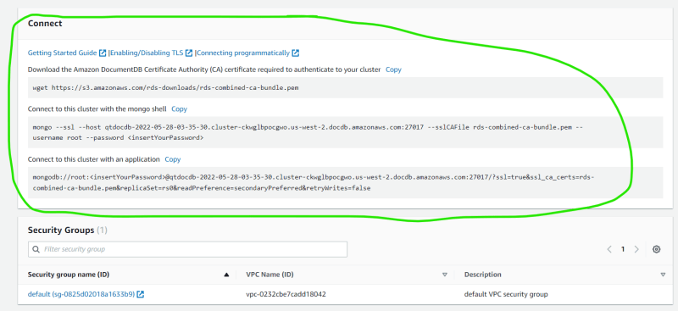
* Snapshots can be created manually or enabled automatically by selecting how many of backup needs to be retained  
  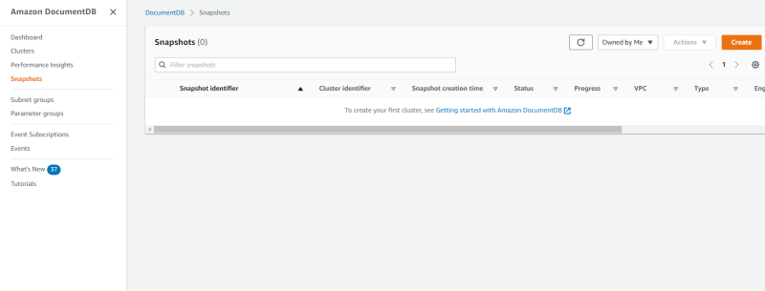  
  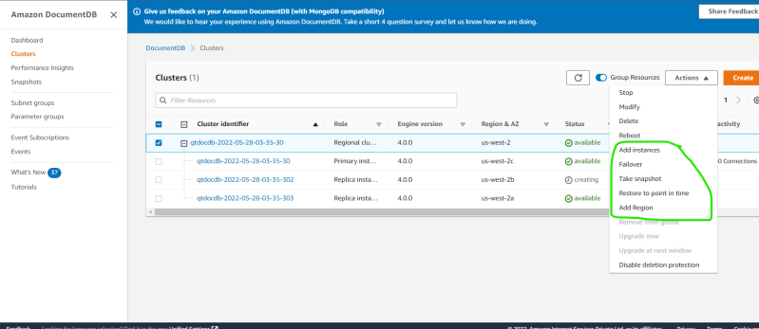

**AWS Key Spaces**

* For Cassandra workloads aws has a fully managed service called as AWS Key Spaces  
  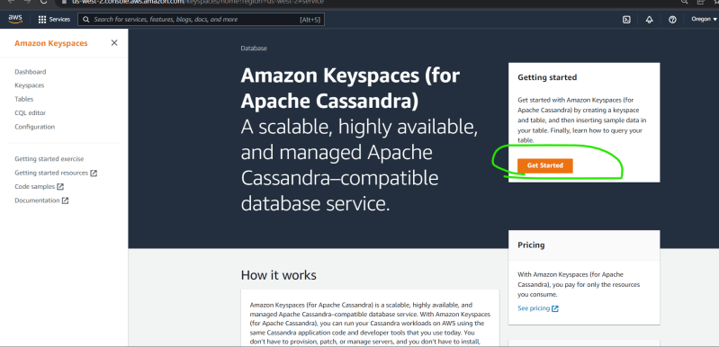  
  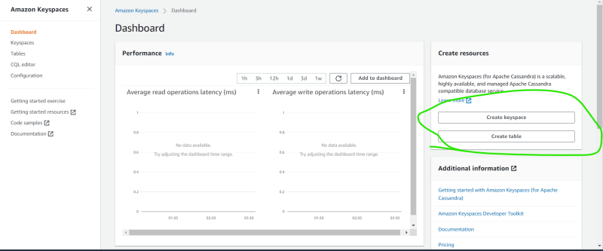

**AWS Elastic Cache**

* AWS Elastic Cache is a fully managed service for two cache server offering
  + Elastic Cache for MemCached
  + Elastic Cache for Redis

**Exercise:**

* Create a pricing estimate for the following (will be waiting till 9:45 AM)  
  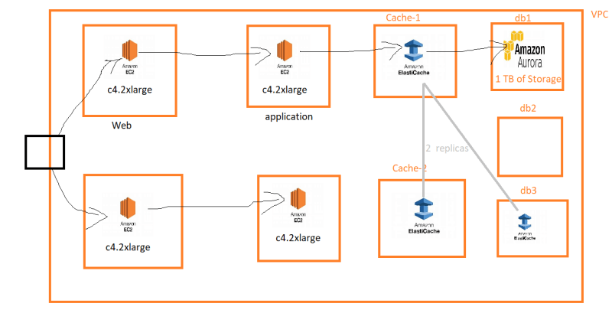

**Other Databases**

* If your application needs a fully managed graph database we can use the AWS Neptune
* For distributed ledger (Block Chain) => QLDB